Semester 2 (Units 3 and 4) Examination, 2017

Question/Answer Booklet

MATHEMATICS METHODS

Section One: Calculator-free

Student Name/Number: ______________________________________________

Teacher Name: ______________________________________________

Time allowed for this section
Reading time before commencing work: five minutes
Working time for this section: fifty minutes

Materials required/recommended for this section
To be provided by the supervisor: This Question/Answer Booklet
Formula Sheet

To be provided by the candidate:
Standard items: pens (blue/black preferred), pencils (including coloured), sharpener, correction fluid/tape, eraser, ruler, highlighters
Special items: nil

Important note to candidates
No other items may be taken into the examination room. It is your responsibility to ensure that you do not have any unauthorised notes or other items of a non-personal nature in the examination room. If you have any unauthorised material with you, hand it to the supervisor before reading any further.

Structure of this paper

Section | Number of questions available | Number of questions to be answered | Working time (minutes) | Marks available | Percentage of exam
Section One: Calculator-free | 9 | 9 | 50 | 52 | 35
Section Two: Calculator-assumed | 13 | 13 | 100 | 99 | 65
 |  |  |  |  | 100

Instructions to candidates

- The rules for the conduct of School exams are detailed in the _______________________________________School/College assessment policy. Sitting this examination implies that you agree to abide by these rules.

- Write your answers in this Question/Answer Booklet.

3. You must be careful to confine your responses to the specific questions asked and to follow any instructions that are specific to a particular question.

- Spare pages are included at the end of this booklet. They can be used for planning your responses and/or as additional space if required to continue an answer.
  - Planning: If you use the spare pages for planning, indicate this clearly at the top of the page.
  - Continuing an answer: If you need to use the space to continue an answer, indicate in the original answer space where the answer is continued, i.e. give the page number. Fill in the number of the question that you are continuing to answer at the top of the page.

- Show all working clearly. Your working should be in sufficient detail to allow your answers to be checked readily and for marks to be awarded for reasoning. Incorrect answers given without supporting reasoning cannot be allocated any marks. For any question or part question worth more than two marks, valid working or justification is required to receive full marks. If you repeat any question, ensure that you cancel the answer you do not wish to have marked.

- It is recommended that you do not use pencil, except in diagrams.

- The Formula Sheet is not to be handed in with your Question/Answer Booklet.

Section One: Calculator-free (53 Marks) Weighting 35%

This section has 9 (nine) questions. Answer all questions. Write your answers in the spaces provided.

Suggested working time: 50 minutes.

Question 1 (6 marks)

- A random variable, G, has the following probability distribution.

Find the value of the constant (1 mark)

g | 1 | 2 | 3 | 4 | 5
Pr (G = g)

- State, with reason(s), whether is a discrete probability distribution. (2 marks)

- For a Binomial distribution with parameters , the mean is 90 and the standard deviation is 6. Determine . (3 marks)

Question 2 (4 marks)

(a) State what you understand by a census. (1 mark)

Each stove produced by AK Appliances is stamped with a unique serial number. AK Appliances produces stoves in batches of 2000. Before selling them, they test a random sample of 5 to see what electric current overload they will take before breaking down.

(b) Give one reason, other than to save time and cost, why a sample is taken rather than a census. (1 mark)

(c) Suggest a suitable method to obtain this sample. (1 mark)

(d) Identify the units to be sampled using this method. (1 mark)

Question 3 (7 marks)

(a) Determine the derivative 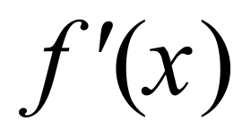 given that

- 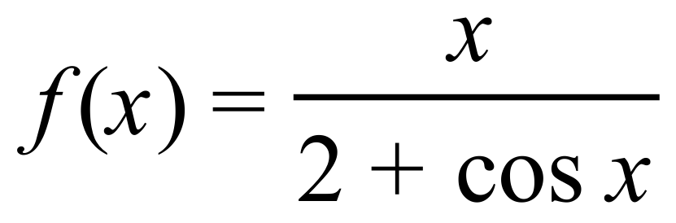 (2 marks)

- 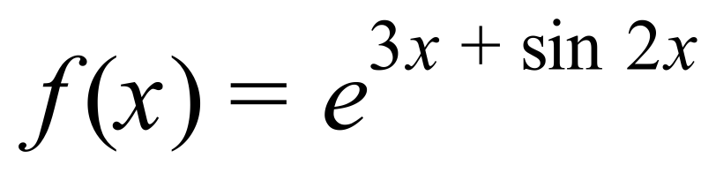 (2 marks)

(b) If show that . (3 marks)

Question 4 (5 marks)

- A number of sample proportions ( ) each of the same size (50) gave rise to the graph shown below.

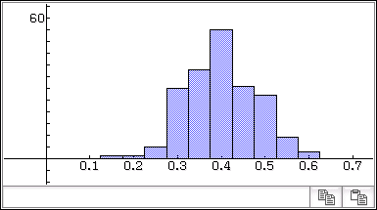
Sample proportions
Number of samples

- Approximately, how many samples were involved (1 mark)

- Estimate , the population proportion. (2 marks)

- A local radio station carries out regular polls of its listeners on items of current interest. In one such poll, listeners were asked to telephone the station and just answer yes or no to the following question:

Should the AFL introduce the red card send-off rule into all games?

The poll was carried out between 8:00 am and 9:00 am one morning.

Give two problems associated with this method of sampling and suggest why each problem might cause misleading conclusions to be drawn. (2 marks)

Question 5 (4 marks)

Determine .

Question 6 (5 marks)

(a) Express 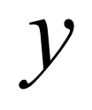 in terms of 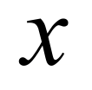 given that . (2 marks)

(b) Suppose that are positive real numbers.

- What is sign of 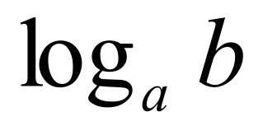 if 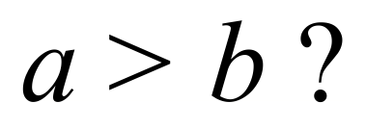 (1 mark)

- Deduce that 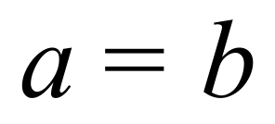 if 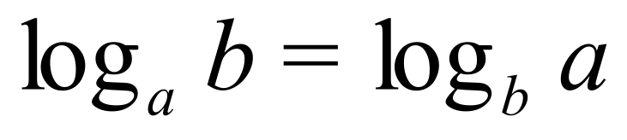 (2 marks)

Question 7 (5 marks)

The graph of the function $f\left(x\right)= - \frac{8}{\sqrt{x}}$ , where x > 0 is shown below. The shaded region is between the graph and the axis from units .
- Write down an expression for the area of the shaded region shown on the graph above. (1 mark)

- Evaluate the area of the shaded region. (2 marks)

(c) Given , where , determine the exact value of a . (2 marks)

Question 8 (9 marks)

(a) Let X be a continuous random variable whose probability density function is for an interval $0<x<c .$ What is the value of the constant $c$ that makes $f(x)$ a valid probability density function? Clearly show all working. (3 marks)

(b) Consider the probability density function $w\left(x\right)=\frac{1}{20}$ where $12≤x≤32$ and $w\left(x\right)=0$ otherwise. Using integration, determine the expected value of $w(x)$. (2 marks)

- 200 vehicles were parked in a parking lot during a 3 hour period. The recorded data is shown on the histogram drawn below.
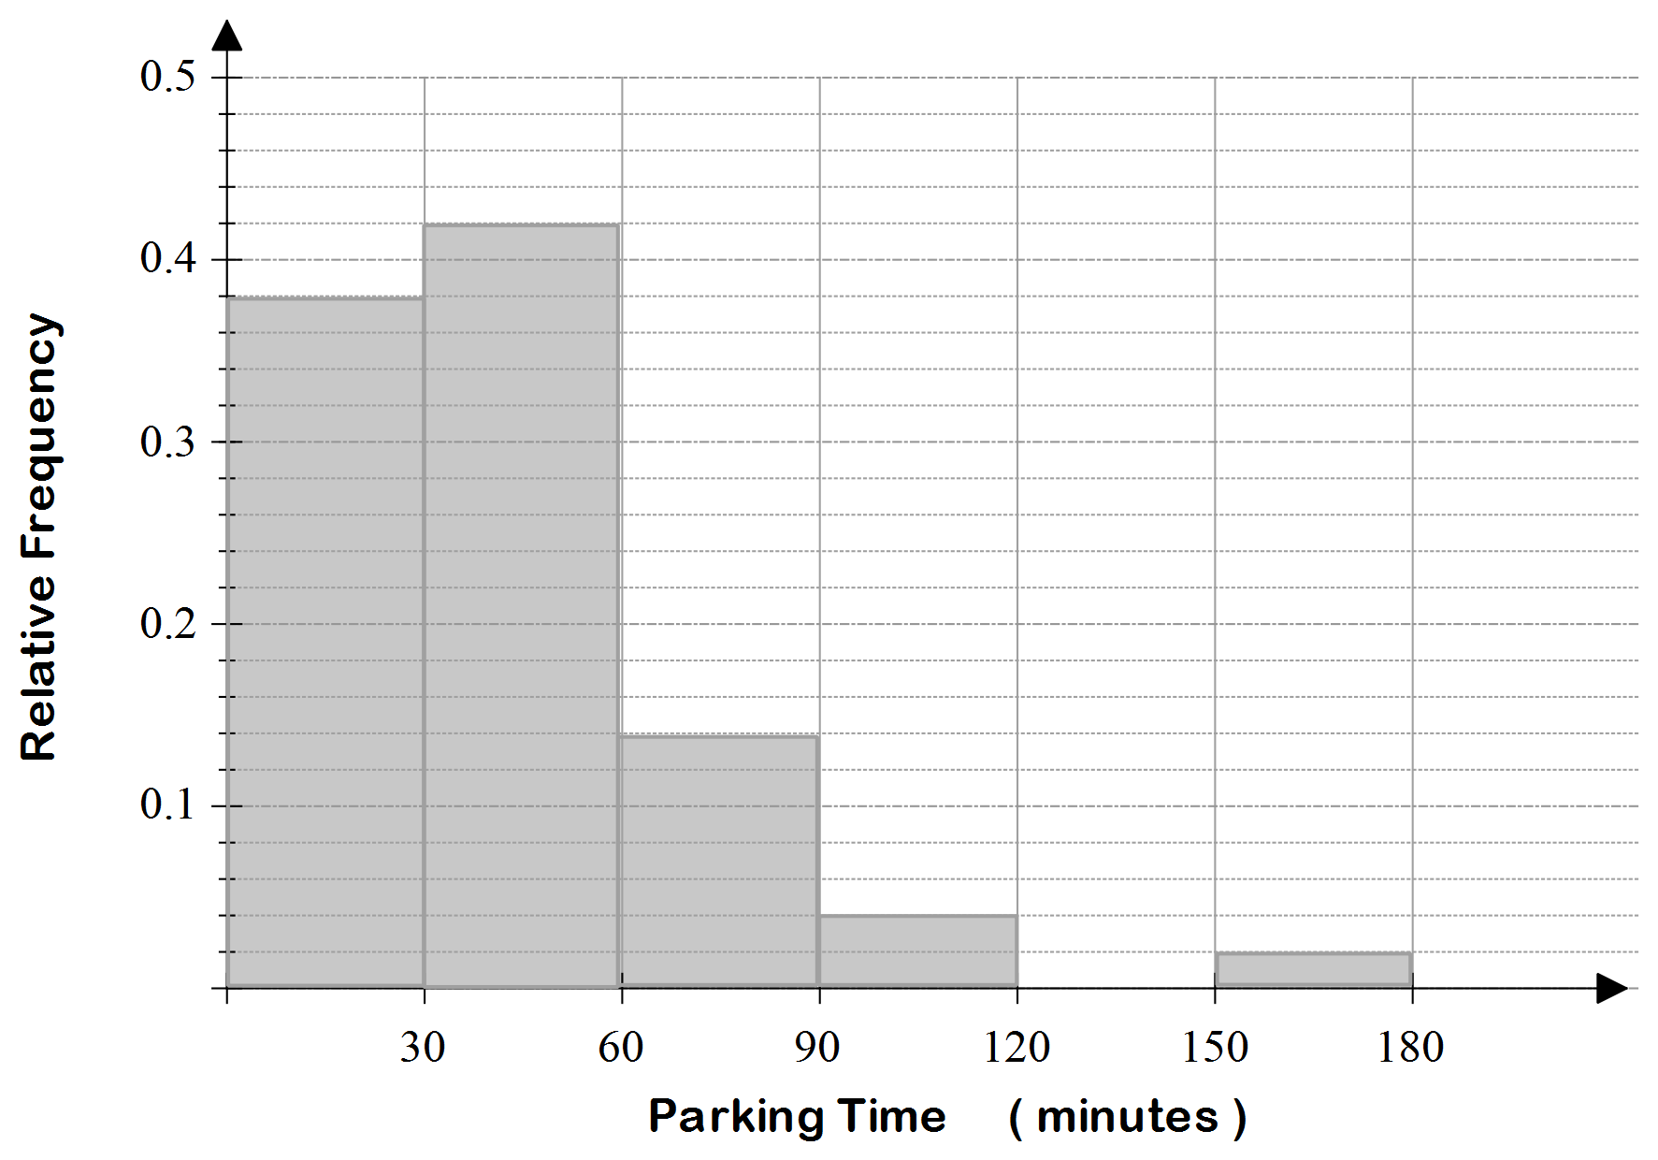

Use this data to answer the following:

(i) Determine the probability that a randomly selected vehicle was parked for at most 60 minutes. (1 mark)

(ii) State the number of vehicles that were parked for between 1 and 1.5hrs. (1 mark)

- Where might you assume that this parking lot was located? Justify your answer. (1 mark)

- As a statistician, you need to analyse and inquire about data to draw conclusions and make suggestions. Different to (c), what is a question you could ask to help understand if there is a bias in collecting this data? (1 mark)

Question 9 (7 marks)

The graph of , where are positive integers, is shown below:

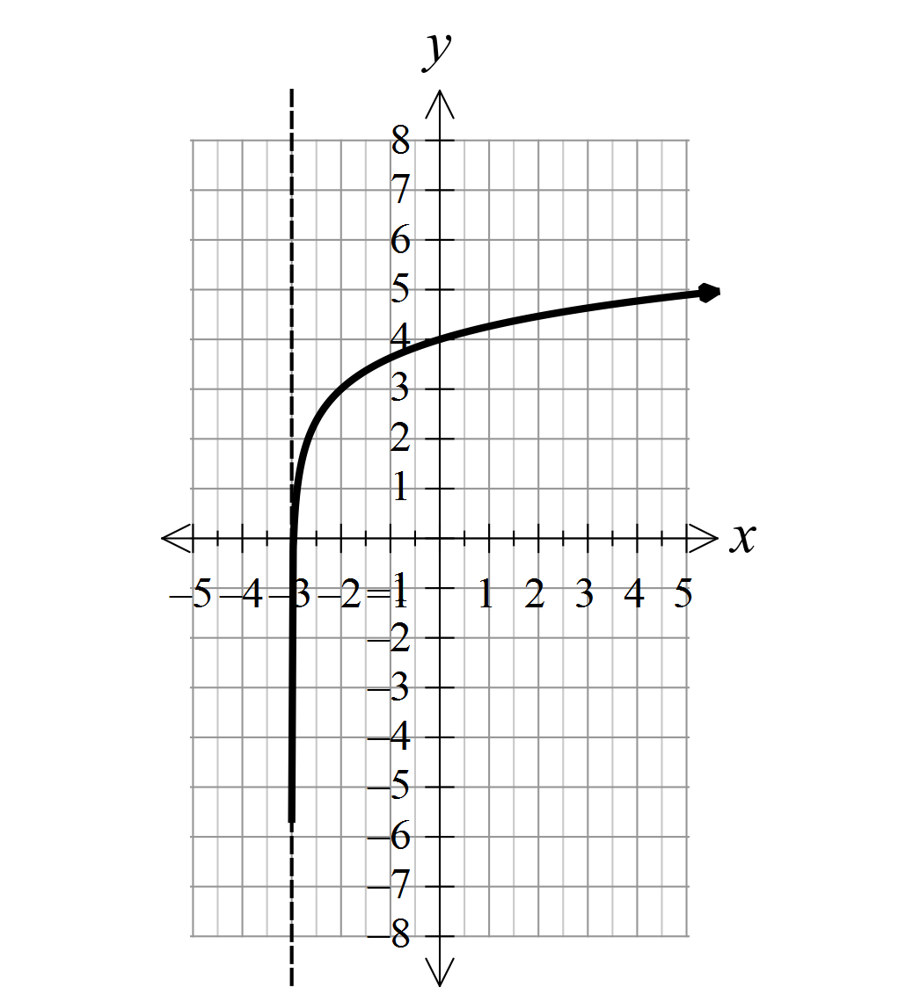

(a) Use the graph to determine the values of . (3 marks)

(b) Sketch on the same axes the graph of . Make sure that you show the intercepts on the two axes accurately. (4 marks)

End of Questions
Additional working space
Question number: __________________

Acknowledgements

© MAWA, 2017
This examination is Copyright but may be freely used within the school that purchases this licence.
- The items that are contained in this examination are to be used solely in the school for which they are purchased.
- They are not to be shared in any manner with a school which has not purchased their own licence.
- The items and the solutions/marking keys are to be kept confidentially and not copied or made available to anyone who is not a teacher at the school. Teachers may give feedback to students in the form of showing them how the work is marked but students are not to retain a copy of the paper or the marking guide until the agreed release date stipulated in the purchasing agreement/licence.
Published by The Mathematical Association of WA
12 Cobbler Place, MIRRABOOKA 6061.

